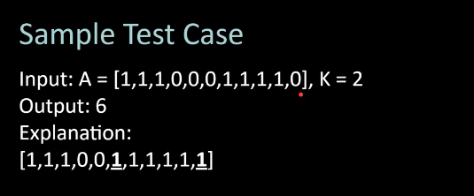
Max no. Of consecutive one’s after chaging k zeros to 1
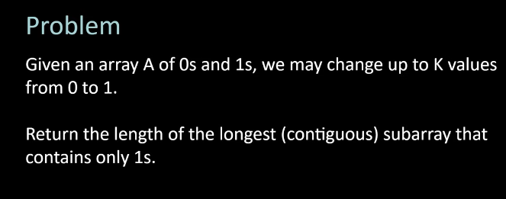

#include<bits/stdc++.h>
using namespace std;

int max_ones(vector<int> a , int n, int k ){
int ans=-1;
int ct_of_zero=0;
int i=0;
for(int j=0 ;j<n ;j++ ){
if(a[j]==0){
ct_of_zero++;
}
while(ct_of_zero>k){
if(a[i]==0){
ct_of_zero--;
}
i++;
}
ans= max(ans,j-i+1);
}
//cout<<ans;
return ans;
}

int main(){
int n, k;
cin>>n>>k;
vector<int>a(n);
for(int i=0 ;i<n ;i++){
cin>>a[i];
}

cout<<max_ones(a,n,k);
}

i/p
5 2
1 1 0 0 1

o/p
5

